Name : Prince Siachin Pasombaran

Parallel - B

No.

1. **Algorithm to count employee's weekly salary.**

Code :

Slide 1. 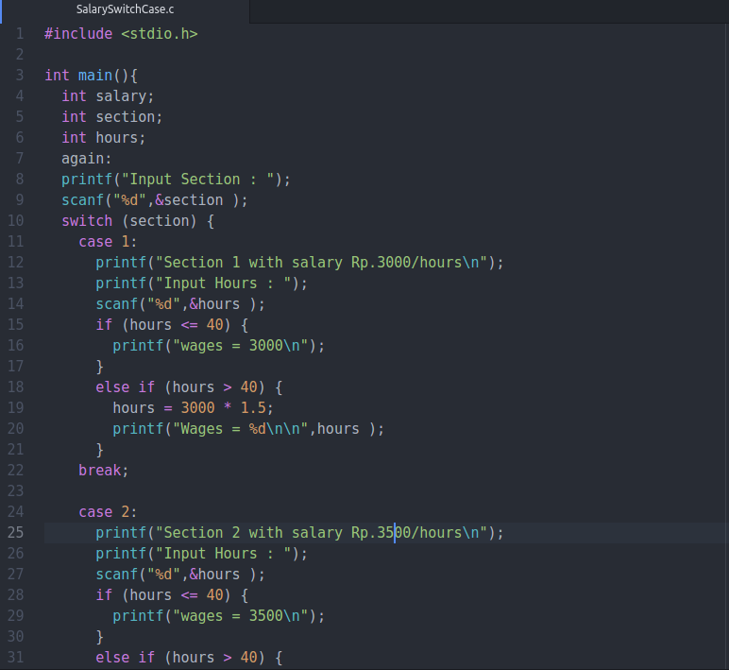

Slide 2.

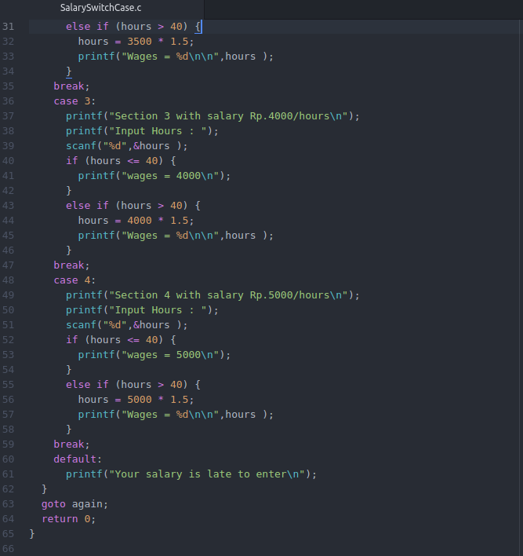

Output.

**Section 1.**

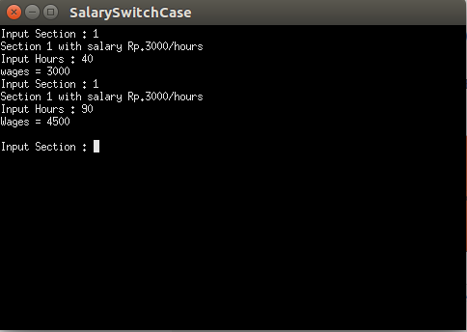

**Section 2.**

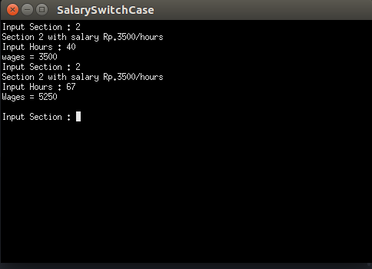

**Section 3.**

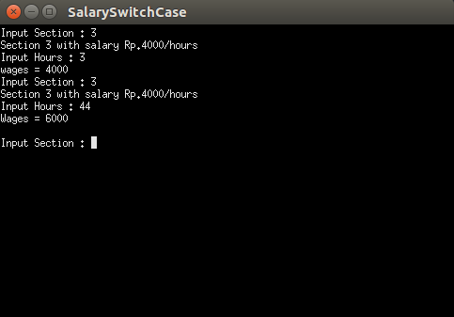

**Section 4.**

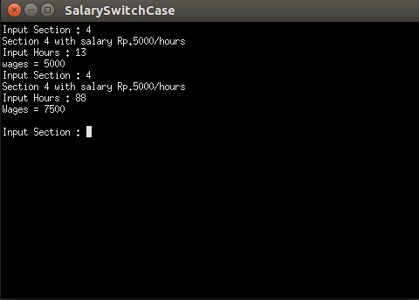

**2. replacement resistor of 3 resistors arranged in series.**

Code**.**

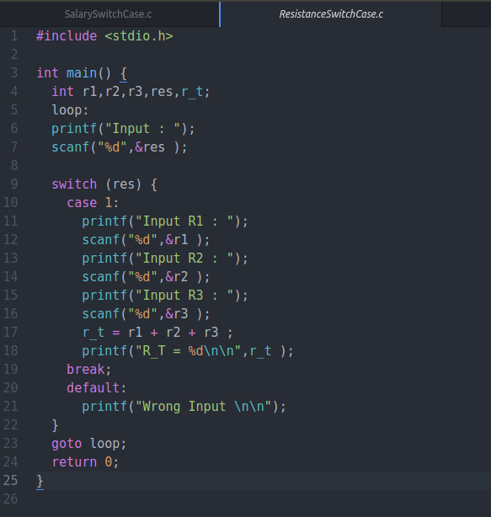

**Output :**

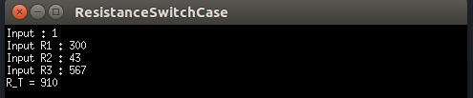

**3. program to determine the name of the day from the past few days.**

Code :

Slide 1.

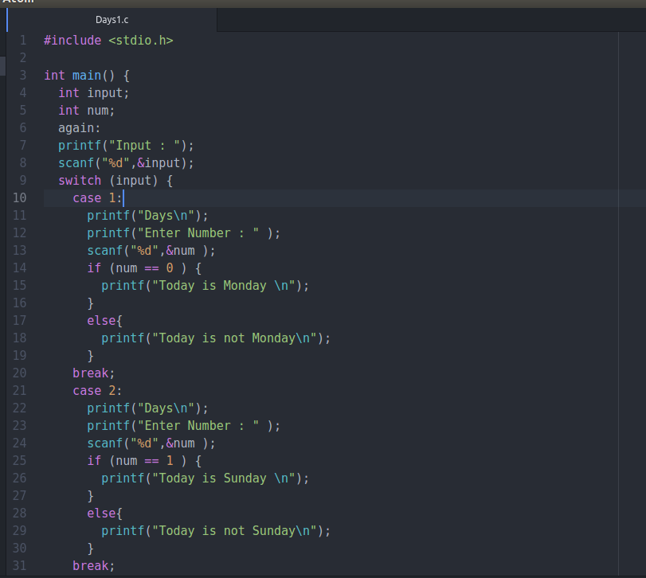

Slide 2.

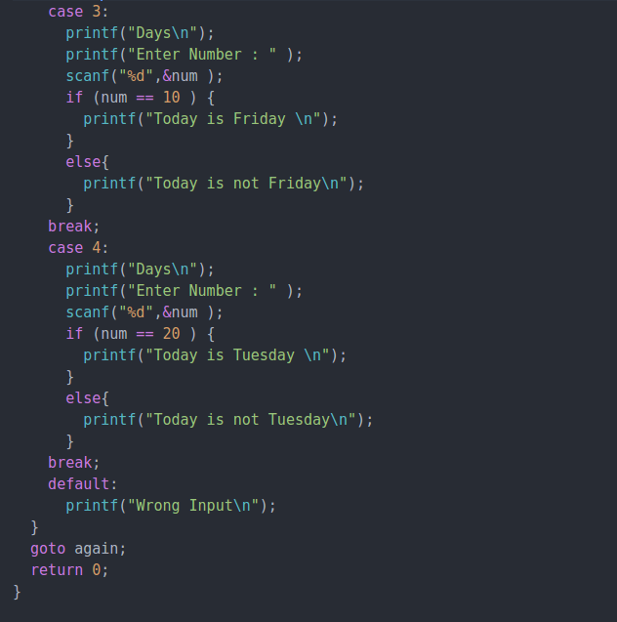

Output :

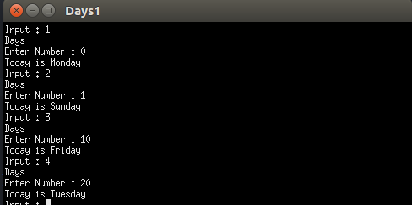

**4. program to determine the name of the day from the past few days and the number of the day that is input.**

Code :

Slide 1.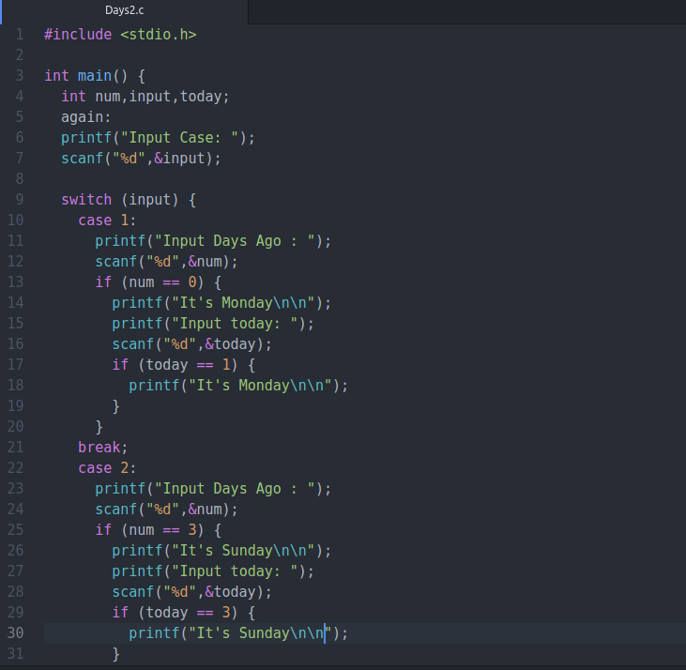

Slide 2.

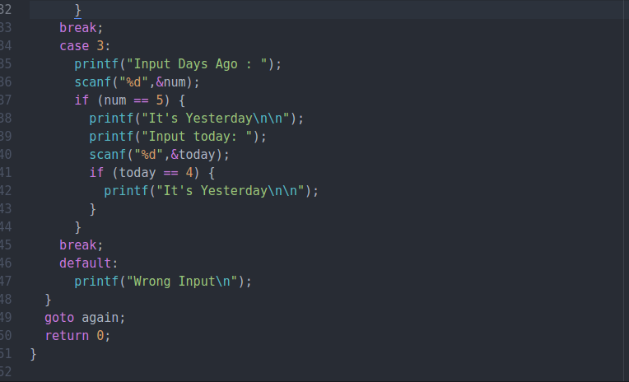

Output :  
